TITLE 1 FALL

ANNUAL MEETING

AGENDA:

What is Title I
- How does Title I help
- Review Parent Compact/Family Policy
- How can parents get involved
- Upcoming events

TUESDAY, SEPTEMBER 21, 2021
8:30 A.M.
WEDNESDAY, SEPTEMBER 22, 2021

1:30 P.M.

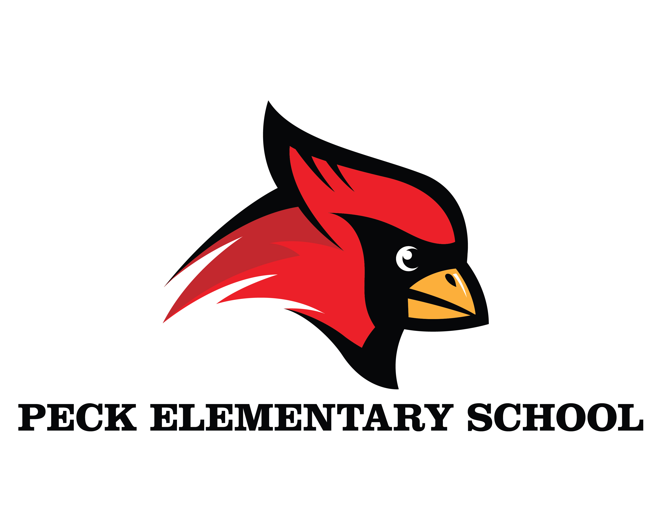


LORA B. PECK ELEMENTARY
5001 M.L.K. Blvd. Houston, Texas 77021
Phone (713)845-7463 Fax (713) 847-4701

Myra Castle- Bell, Principal Jennifer Whittie, Assistant Principal


